1. **Analyze images**

**Introduction**

Azure AI Vision is a branch of artificial intelligence (AI) in which software interprets visual input, often from images or video feeds.

**Provision an Azure AI Vision resource**

The **Azure AI Vision** service is designed to help you extract information from images. It provides functionality that you can use for:

* *Description and tag generation* - determining an appropriate caption for an image, and identifying relevant "tags" that can be used as keywords to indicate its subject.
* *Object detection* - detecting the presence and location of specific objects within the image.
* *People detection* - detecting the presence, location, and features of people in the image.
* *Image metadata, color, and type analysis* - determining the format and size of an image, its dominant color palette, and whether it contains clip art.
* *Category identification* - identifying an appropriate categorization for the image, and if it contains any known landmarks.
* *Background removal* - detecting the background in an image and output the image with the background transparent or a greyscale alpha matte image.
* *Moderation rating* - determine if the image includes any adult or violent content.
* *Optical character recognition* - reading text in the image.
* *Smart thumbnail generation* - identifying the main region of interest in the image to create a smaller "thumbnail" version.

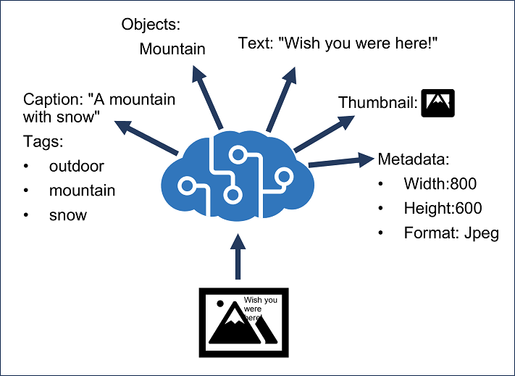

You can provision **Azure AI Vision** as a single-service resource, or you can use the Azure AI Vision API in a multi-service **Azure AI Services** resource.

**Note**

In this module, we'll focus on the image analysis and thumbnail generation capabilities of the Azure AI Vision service. To learn how to use the Azure AI Vision service for optical character recognition, check out the [**Read Text in images and documents with the Azure AI Vision service**](https://learn.microsoft.com/en-us/training/modules/read-text-images-documents-with-computer-vision-service/) module.

**Analyze an image**

To analyze an image, you can use the Analyze Image REST method or the equivalent method in the SDK for your preferred programming language, specifying the visual features you want to include in the analysis (and if you select categories, whether or not to include details of celebrities or landmarks). This method returns a JSON document containing the requested information.

 Note

Detection of celebrities will require getting approved through a [Limited Access policy](https://aka.ms/cog-services-limited-access). You can read more about the [addition of this policy](https://azure.microsoft.com/blog/responsible-ai-investments-and-safeguards-for-facial-recognition/) to our Responsible AI standard. Celebrity recognition is seen in some screenshots, however is not included in the lab.

from azure.ai.vision.imageanalysis import ImageAnalysisClient

from azure.ai.vision.imageanalysis.models import VisualFeatures

from azure.core.credentials import AzureKeyCredential

client = ImageAnalysisClient(

endpoint=os.environ["ENDPOINT"],

credential=AzureKeyCredential(os.environ["KEY"])

)

result = client.analyze(

image_url="<url>",

visual_features=[VisualFeatures.CAPTION, VisualFeatures.READ],

gender_neutral_caption=True,

language="en",)

Available visual features are contained in the VisualFeatures enum:

* VisualFeatures.TAGS: Identifies tags about the image, including objects, scenery, setting, and actions
* VisualFeatures.OBJECTS: Returns the bounding box for each detected object
* VisualFeatures.CAPTION: Generates a caption of the image in natural language
* VisualFeatures.DENSE_CAPTIONS: Generates more detailed captions for the objects detected
* VisualFeatures.PEOPLE: Returns the bounding box for detected people
* VisualFeatures.SMART_CROPS: Returns the bounding box of the specified aspect ratio for the area of interest
* VisualFeatures.READ: Extracts readable text

Specifying the visual features you want analyzed in the image determines what information the response will contain. Most responses will contain a bounding box (if a location in the image is reasonable) or a confidence score (for features such as tags or captions).

The JSON response for image analysis looks similar to this example, depending on your requested features:

{

"apim-request-id": "abcde-1234-5678-9012-f1g2h3i4j5k6",

"modelVersion": "<version>",

"denseCaptionsResult": {

"values": [

{

"text": "a house in the woods",

"confidence": 0.7055229544639587,

"boundingBox": {

"x": 0,

"y": 0,

"w": 640,

"h": 640

}

},

{

"text": "a trailer with a door and windows",

"confidence": 0.6675070524215698,

"boundingBox": {

"x": 214,

"y": 434,

"w": 154,

"h": 108

}

}

]

},

"metadata": {

"width": 640,

"height": 640

}

}

**Generate a smart-cropped thumbnail and remove background**

Thumbnails are often used to provide smaller versions of images in applications and websites. For example, a tourism site might display a list of tourist attractions in a city with a small, representative thumbnail image for each attraction; and only display the full image when the user selects the "details" page for an individual attraction.

The Azure AI Vision service enables you to create a thumbnail with different dimensions (and aspect ratio) from the source image, and optionally to use image analysis to determine the *region of interest* in the image (its main subject) and make that the focus of the thumbnail. This ability to determine the region of interest is especially useful when cropping the image to change its aspect ratio.

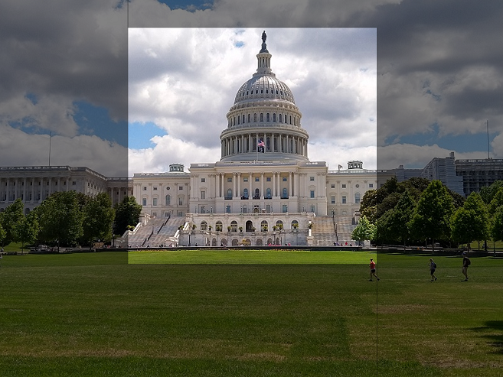

You can specify the aspect ratio of the cropped image (width / height), ranging from 0.75 to 1.80.

**Remove image background**

The background removal feature can split the image into the subject in the foreground, and everything else that is considered background. Azure AI Vision achieves this feature by creating an *alpha matte* of the foreground subject, which is then used to return either the foreground or the background.

For example, take this image original of a skateboarder.

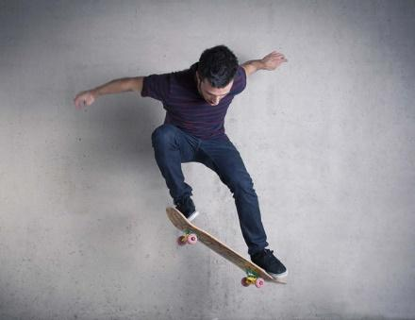

With the background removed, we get just the skateboarder on a transparent background.

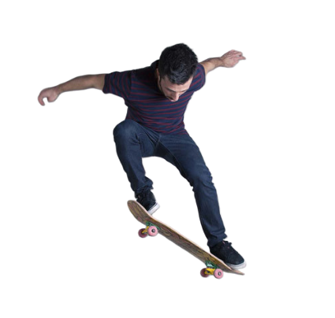

When creating an alpha matte of an image, the result is the foreground in all white, with a black background.



Alpha matte images are helpful when client applications intend to do further processing of an image that requires separation of foreground and background objects.

**Knowledge Check**

**1. You want to use the Azure AI Vision Analyze Image function to generate an appropriate caption for an image. Which visual feature should you specify?**

Tags

DenseCaptions

**That's correct. To generate a caption, include the DenseCaptions visual feature in your analysis.**

Objects

**2. What is the purpose of the Azure AI Vision service?**

To provide functionality for audio transcription

To extract information from images

**The Azure AI Vision service is designed to help you extract information from images through various functionalities.**

To detect the presence and location of specific sounds within an audio file

**Classify images**

**Introduction**

*Image classification* is a common computer vision problem that requires software to analyze an image in order to categorize (or *classify*) it. In this module, you will learn how the Azure AI Custom Vision service enables you to build your own computer vision models for image classification.

**Provision Azure resources for Azure AI Custom Vision**

The **Azure AI Custom Vision** service enables you to build your own computer vision models for *image classification* or *object detection*.

Creating an Azure AI Custom Vision solution involves two tasks:

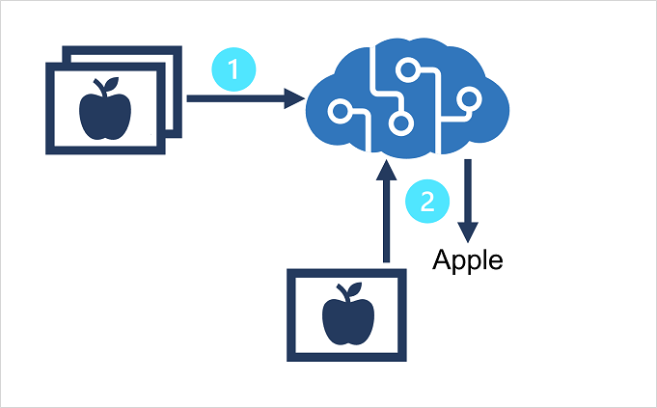

1. Use existing (labeled) images to train an Azure AI Custom Vision model.
2. Create a client application that submits new images to your model to generate predictions.

To use the Azure AI Custom Vision service, you must provision two kinds of Azure resource:

* A *training* resource used to train your models. This can be:
  + An **Azure AI services multi-service** resource.
  + An **Azure AI Custom Vision (Training)** resource.
* A *prediction* resource, used by client applications to get predictions from your model. This can be:
  + An **Azure AI services multi-service** resource.
  + An **Azure AI Custom Vision (Prediction)** resource.

You can use a **Azure AI services multi-service** resource for both training and prediction, and you can mix-and-match resource types (for example, using an **Azure AI Custom Vision (Training)** resource to train a model that you then publish using an **Azure AI services multi-service** resource). If using a multi-service resource, they key and endpoint for both training and prediction will be the same.

**Understand image classification**

*Image classification* is a computer vision technique in which a model is trained to predict a class label for an image based on its contents. Usually, the class label relates to the main *subject* of the image.

For example, the following images have been classified based on the type of fruit they contain.

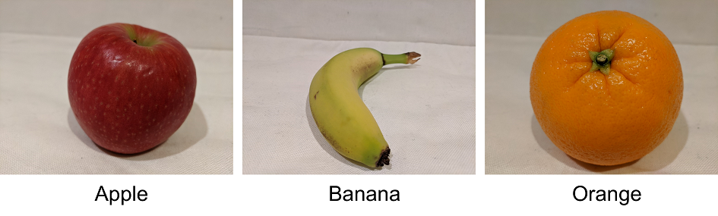

Models can be trained for multiclass classification (in other words, there are multiple classes, but each image can belong to only one class) or multilabel classification (in other words, an image might be associated with multiple labels).

**Train an image classifier**

To train an image classification model with the Azure AI Custom Vision service, you can use the Azure AI Custom Vision portal, the Azure AI Custom Vision REST API or SDK, or a combination of both approaches.

In most cases, you'll typically use the Azure AI Custom Vision portal to train your model.

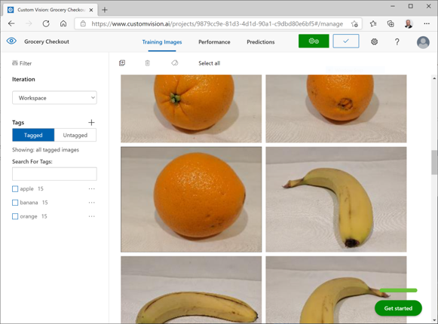

The portal provides a graphical interface that you can use to:

1. Create an image classification project for your model and associate it with a training resource.
2. Upload images, assigning class label tags to them.
3. Review and edit tagged images.
4. Train and evaluate a classification model.
5. Test a trained model.
6. Publish a trained model to a prediction resource.

The REST API and SDKs enable you to perform the same tasks by writing code, which is useful if you need to automate model training and publishing as part of a DevOps process.

**Knowledge Check**

1. You want to train a model that can categorize an image as "cat" or "dog" based on its subject. What kind of Azure AI Custom Vision project should you create?

Image classification (multiclass)

That's correct. To train a model that classifies an image using a single tag, use an Image classification (multiclass) project.

Image classification (multilabel)

Object detection

2. Which of the following kinds of Azure resource can you use to host a trained Azure AI Custom Vision model?

Azure AI Custom Vision (Training)

Azure AI Vision

Azure AI Services

That's correct. You can publish a trained Azure AI Custom Vision model to either an Azure AI Custom Vision (Prediction) resource or an Azure AI Services multi-service resource.

**Detect objects in images**

**Introduction**

*Object detection* is a common computer vision problem that requires software to identify the location of specific classes of object in an image. In this module, you will learn how to use the Azure AI Custom Vision service to create object detection models.

**Understand object detection**

*Object detection* is a form of computer vision in which a model is trained to detect the presence and location of one or more classes of object in an image. For example, an AI-enabled checkout system in a grocery store might need to identify the type and location of items being purchased by a customer.

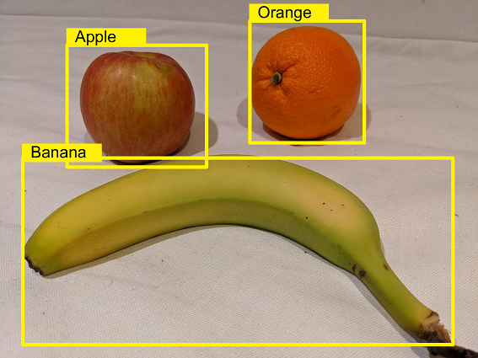

There are two components to an object detection prediction:

* The class label of each object detected in the image. For example, you might ascertain that an image contains one apple and two oranges.
* The location of each object within the image, indicated as coordinates of a *bounding box* that encloses the object.

**Use the Azure AI Custom Vision service for object detection**

You can use the **Azure AI Custom Vision** service to train an object detection model. To use the Azure AI Custom Vision service, you must provision two kinds of Azure resource:

* A *training* resource used to train your models. This can be:
  + An **Azure AI services multi-service** resource.
  + An **Azure AI Custom Vision (Training)** resource.
* A *prediction* resource, used by client applications to get predictions from your model. This can be:
  + An **Azure AI services multi-service** resource.
  + An **Azure AI Custom Vision (Prediction)** resource.

You can use a **Azure AI services multi-service** resource for both training and prediction, and you can mix-and-match resource types (for example, using an **Azure AI Custom Vision (Training)** resource to train a model that you then publish using an **Azure AI services multi-service** resource). If using a multi-service resource, the key and endpoint for both training and prediction will be the same.

**Train an object detector**

To train an object detection model, you can use the Azure AI Custom Vision portal to upload and label images before training, evaluating, testing, and publishing the model; or you can use the REST API or SDK to write code that performs the training tasks.

The most significant difference between training an *image classification* model and training an *object detection* model is the labeling of the images with tags. While image classification requires one or more tags that apply to the whole image, object detection requires that each label consists of a tag and a *region* that defines the bounding box for each object in an image. The Azure AI Custom Vision portal provides a graphical interface that you can use to label your training images.

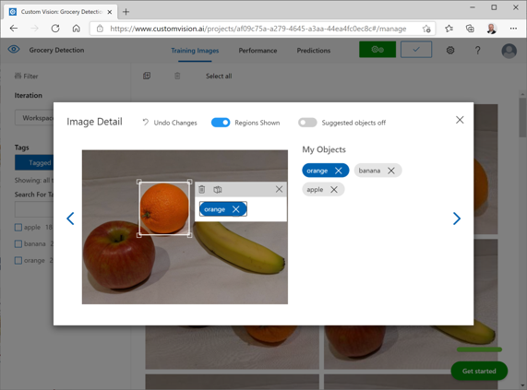

**Consider options for labeling images**

The easiest option for labeling images for object detection is to use the interactive interface in the Azure AI Custom Vision portal. This interface automatically suggests regions that contain objects, to which you can assign tags or adjust by dragging the bounding box to enclose the object you want to label.

Additionally, after tagging an initial batch of images, you can train the model. Subsequent labeling of new images can benefit from the *smart labeler* tool in the portal, which can suggest not only the regions, but the classes of object they contain.

Alternatively, you can use a labeling tool, such as the one provided in [Azure Machine Learning Studio](https://learn.microsoft.com/en-us/azure/machine-learning/how-to-label-data) or the [Microsoft Visual Object Tagging Tool (VOTT)](https://github.com/microsoft/VoTT/blob/master/README.md), to take advantage of other features, such as assigning image labeling tasks to multiple team members.

**Bounding box measurement units**

If you choose to use a labeling tool other than the Azure AI Custom Vision portal, you may need to adjust the output to match the measurement units expected by the Azure AI Custom Vision API. Bounding boxes are defined by four values that represent the left (X) and top (Y) coordinates of the top-left corner of the bounding box, and the width and height of the bounding box. These values are expressed as *proportional* values relative to the source image size. For example, consider this bounding box:

* Left: 0.1
* Top: 0.5
* Width: 0.5
* Height: 0.25

This defines a box in which the left is located 0.1 (one tenth) from the left edge of the image, and the top is 0.5 (half the image height) from the top. The box is half the width and a quarter of the height of the overall image.

The following image shows labeling information in JSON format for objects in an image.

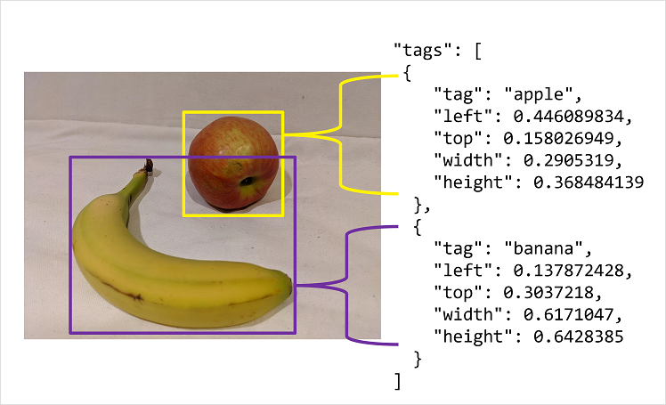

**Knowledge Check**

1. What does an object detection model predict?

The location and class of specific classes of object in an image.

That's correct. Object detection is used to identify bounding boxes containing specific classes of object in an image.

The class of the main subject of an image.

The file type of an image.

2. What must you do before taking advantage of the smart labeler tool when creating an object detection model?

Create a JSON file containing bounding box coordinates.

Tag some images with objects of each class and train an initial object detection model.

That's correct. To take advantage of the smart labeler, tag some images and train an initial model. Subsequently, the portal will suggest tags for new images.

Train an image classification (multilabel) model.

**Detect, analyze, and recognize faces**

**Introduction**

Face detection, analysis, and recognition are all common computer vision challenges for AI systems. The ability to detect when a person is present, identify a person's facial location, or recognize an individual based on their facial features is a key way in which AI systems can exhibit human-like behavior and build empathy with users.

In this module, you'll learn how to detect, analyze, and recognize faces using Azure AI Services.

**Identify options for face detection analysis and identification**

There are two Azure AI services that you can use to build solutions that detect faces or people in images.

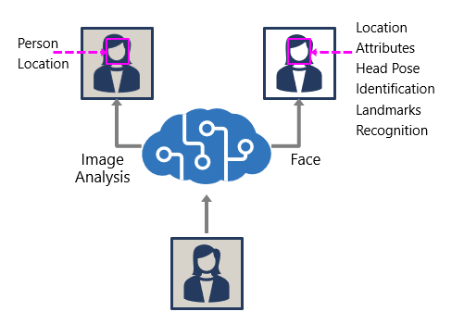

**The Azure AI Vision service**

The Azure AI Vision service enables you to detect people in an image, as well as returning a bounding box for its location.

**The Face service**

The Face service offers more comprehensive facial analysis capabilities than the Azure AI Vision service, including:

* Face detection (with bounding box).
* Comprehensive facial feature analysis (including head pose, presence of spectacles, blur, facial landmarks, occlusion and others).
* Face comparison and verification.
* Facial recognition.

 Important

Usage of facial recognition, identification, comparison, and verification will require getting approved through a [Limited Access policy](https://aka.ms/cog-services-limited-access). You can read more about the [addition of this policy](https://azure.microsoft.com/blog/responsible-ai-investments-and-safeguards-for-facial-recognition/) to our Responsible AI standard. Facial recognition will be touched on in the rest of this module, but will be unavailable without applying for Limited Access.

**Understand considerations for face analysis**

While all applications of artificial intelligence require considerations for responsible and ethical use, system that rely on facial data can be particularly problematic.

When building a solution that uses facial data, considerations include (but aren't limited to):

* **Data privacy and security**. Facial data is personally identifiable, and should be considered sensitive and private. You should ensure that you have implemented adequate protection for facial data used for model training and inferencing.
* **Transparency**. Ensure that users are informed about how their facial data is used, and who will have access to it.
* **Fairness and inclusiveness**. Ensure that your face-based system can't be used in a manner that is prejudicial to individuals based on their appearance, or to unfairly target individuals.

**Detect faces with the Azure AI Vision service**

To detect and analyze faces with the Azure AI Vision service, call the **Analyze Image** function (SDK or equivalent REST method), specifying **People** as one of the visual features to be returned.

In images that contain one or more people, the response includes details of their location in the image and the attributes of the detected person, like this:

{

"modelVersion": "2023-10-01",

"metadata": {

"width": 400,

"height": 600

},

"peopleResult": {

"values": [

{

"boundingBox": {

"x": 0,

"y": 56,

"w": 101,

"h": 189

},

"confidence": 0.9474349617958069

},

{

"boundingBox": {

"x": 402,

"y": 96,

"w": 124,

"h": 156

},

"confidence": 0.9310565276194865

},

...

]

}

}

 Note

Azure AI Vision previously included age and gender prediction, however that has been removed as a safeguard for responsible use.

**Understand capabilities of the face service**

The **Face** service provides comprehensive facial detection, analysis, and recognition capabilities.

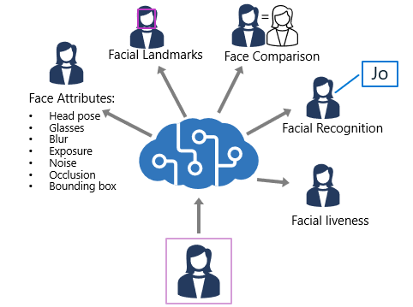

The Face service provides functionality that you can use for:

* *Face detection* - for each detected face, the results include an ID that identifies the face and the bounding box coordinates indicating its location in the image.
* *Face attribute analysis* - you can return a wide range of facial attributes, including:
  + Head pose (*pitch*, *roll*, and *yaw* orientation in 3D space)
  + Glasses (*NoGlasses*, *ReadingGlasses*, *Sunglasses*, or *Swimming Goggles*)
  + Blur (*low*, *medium*, or *high*)
  + Exposure (*underExposure*, *goodExposure*, or *overExposure*)
  + Noise (visual noise in the image)
  + Occlusion (objects obscuring the face)
  + Accessories (glasses, headwear, mask)
  + QualityForRecognition (*low*, *medium*, or *high*)
* *Facial landmark location* - coordinates for key landmarks in relation to facial features (for example, eye corners, pupils, tip of nose, and so on)
* *Face comparison* - you can compare faces across multiple images for similarity (to find individuals with similar facial features) and verification (to determine that a face in one image is the same person as a face in another image)
* *Facial recognition* - you can train a model with a collection of faces belonging to specific individuals, and use the model to identify those people in new images.
* *Facial liveness* - liveness can be used to determine if the input video is a real stream or a fake to prevent bad intentioned individuals from spoofing the recognition system.

You can provision **Face** as a single-service resource, or you can use the Face API in a multi-service **Azure AI Services** resource.

If you want to use the identification, recognition, and verification features of **Face**, you'll need to apply for the [Limited Access policy](https://aka.ms/cog-services-limited-access) and get approval before these features are available.

**Compare and match detected faces**

When a face is detected by the Face service, a unique ID is assigned to it and retained in the service resource for 24 hours. The ID is a GUID, with no indication of the individual's identity other than their facial features.

**Important**

Usage of facial recognition, comparison, and verification will require getting approved through a [**Limited Access policy**](https://aka.ms/cog-services-limited-access). You can read more about the [**addition of this policy**](https://azure.microsoft.com/blog/responsible-ai-investments-and-safeguards-for-facial-recognition/) to our Responsible AI standard. Facial recognition will be unavailable to new customers until they are granted the Limited Access policy.

While the detected face ID is cached, subsequent images can be used to compare the new faces to the cached identity and determine if they are *similar* (in other words, they share similar facial features) or to *verify* that the same person appears in two images.

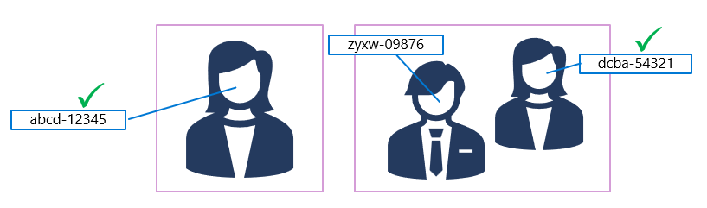

This ability to compare faces anonymously can be useful in systems where it's important to confirm that the same person is present on two occasions, without the need to know the actual identity of the person. For example, by taking images of people as they enter and leave a secured space to verify that everyone who entered leaves.

**Implement facial recognition**

For scenarios where you need to positively identify individuals, you can train a facial recognition model using face images.

**Note**

As mentioned in the previous unit, recognition models will require getting approved through a [**Limited Access policy**](https://aka.ms/cog-services-limited-access).

To train a facial recognition model with the Face service:

1. Create a **Person Group** that defines the set of individuals you want to identify (for example, *employees*).
2. Add a **Person** to the **Person Group** for each individual you want to identify.
3. Add detected faces from multiple images to each **person**, preferably in various poses. The IDs of these faces will no longer expire after 24 hours (so they're now referred to as *persisted* faces).
4. Train the model.

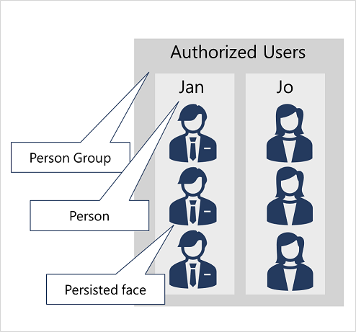

The trained model is stored in your Face (or Azure AI Services) resource, and can be used by client applications to:

* *Identify* individuals in images.
* *Verify* the identity of a detected face.
* Analyze new images to find faces that are *similar* to a known, persisted face.

**Knowledge Check**

1. Which of the following facial attributes can the Azure AI Vision service predict?

Location.

That's correct. The Azure AI Vision service predicts location for a detected face.

Type of eye-glasses.

Occlusion.

2. You need to create a facial recognition solution to identify named employees. Which service should you use?

Azure AI Vision.

Azure AI Custom Vision.

Face.

That's correct. Use the Face service to create a facial recognition solution.

3. You need to verify that the person in a photo taken at hospital reception is the same person in a photo taken at a ward entrance 10 minutes later. What should you do?

Create a People Group and add a person for every hospital visitor with multiple photographs to train a model.

Verify the face in the ward photo by comparing it to the detected face ID from the reception photo.

That's correct. The most efficient approach is to compare the two faces using the detected face ID within 24 hours.

Compare the Age, head pose, and hair color for the faces in the reception and ward photo's.

# 

# **Read Text in images and documents with the Azure AI Vision Service**

# **Introduction**

Suppose you are given thousands of images and asked to transfer the text on the images to a computer database. The scanned images have text organized in different formats and contain multiple languages. What are some ways you could complete the project in a reasonable time frame and make sure the data is entered with a high degree of accuracy?

Companies around the world are tackling similar scenarios every day. Without AI services, it would be challenging to complete the project, especially if it were to change in scale.

Using AI services, we can treat this project as an Azure AI Vision scenario and apply Optical Character Recognition (OCR). OCR allows you to extract text from images, such as photos of street signs and products, as well as from documents — such as handwritten or unstructured documents.

To build an automated AI solution, you need to train machine learning models to cover many use cases. Azure AI Vision service gives access to advanced algorithms for processing images and returns data to secure storage.

# **Explore Azure AI Vision options for reading text**

Azure AI provides two different features that read text from documents and images, one in the Azure AI Vision Service, the other in Azure AI Document Intelligence. There is overlap in what each service provides, however each is optimized for results depending on what the input is.

* Image Analysis Optical character recognition (OCR):
  + Use this feature for general, unstructured documents with smaller amount of text, or images that contain text.
  + Results are returned immediately (synchronous) from a single API call.
  + Has functionality for analyzing images past extracting text, including object detection, describing or categorizing an image, generating smart-cropped thumbnails and more.
  + Examples include: street signs, handwritten notes, and store signs.
* Document Intelligence:
  + Use this service to read small to large volumes of text from images and PDF documents.
  + This service uses context and structure of the document to improve accuracy.
  + The initial function call returns an asynchronous operation ID, which must be used in a subsequent call to retrieve the results.
  + Examples include: receipts, articles, and invoices.

You can access both technologies via the REST API or a client library. In this module, we'll focus on the OCR feature in Image Analysis. If you'd like to learn more about Document Intelligence, [reading this module](https://learn.microsoft.com/en-us/training/modules/use-prebuilt-form-recognizer-models/) will provide a good introduction.

# **Use the Read API**

To use the Read OCR feature, call the ImageAnalysis function (REST API or equivalent SDK method), passing the image URL or binary data, and optionally specifying a gender neutral caption or the language the text is written in (with a default value of en for English).

To make an OCR request to ImageAnalysis, specify the visual feature as READ.

result = client.analyze(

image_url=<image_to_analyze>,

visual_features=[VisualFeatures.READ]

)

If using the REST API, specify the feature as read.

https://<endpoint>/computervision/imageanalysis:analyze?features=read&...

The results of the Read OCR function are returned synchronously, either as JSON or the language specific object of a similar structure. These results are broken down in blocks (with the current service only using one block), then lines, and then words. Additionally, the text values are included at both the line and word levels, making it easier to read entire lines of text if you don't need to extract text at the individual word level.

{

"metadata":

{

"width": 500,

"height": 430

},

"readResult":

{

"blocks":

[

{

"lines":

[

{

"text": "Hello World!",

"boundingPolygon":

[

{"x":251,"y":265},

{"x":673,"y":260},

{"x":674,"y":308},

{"x":252,"y":318}

],

"words":

[

{

"text":"Hello",

"boundingPolygon":

[

{"x":252,"y":267},

{"x":307,"y":265},

{"x":307,"y":318},

{"x":253,"y":318}

],

"confidence":0.996

},

{

"text":"World!",

"boundingPolygon":

[

{"x":318,"y":264},

{"x":386,"y":263},

{"x":387,"y":316},

{"x":319,"y":318}

],

"confidence":0.99

}

]

},

]

}

]

}

}

**Knowledge Check**

1. Which API would be best for this scenario? You need to read a large number of files with high accuracy. The text is short sections of handwritten text, some in English and some of it is in multiple languages.

A custom Language API

Document Intelligence API

Image Analysis API

Correct: The Image Analysis service OCR feature is best suited for short sections of handwritten text.

2. What levels of division are the OCR results returned?

Only total content and pages of text.

Blocks, words and lines of text.

Correct: Results contain blocks, words and lines, as well as bounding boxes for each word and line.

Total content, image tags, pages, words and lines of text.

3. You've scanned a letter into PDF format and need to extract the text it contains. What should you do?

Use the Azure AI Custom Vision service

Use the Image Analysis API of the Azure AI Vision service.

Use the Document Intelligence API.

Correct: The Document Intelligence API can be used to process PDF formatted files.

# **Analyze video**

# **Introduction**

It's increasingly common for organizations and individuals to generate content in video format. For example, you might use a cellphone to capture a live event, or you might record a teleconference that combines webcam footage and presentation of slides or documents. As a result, a great deal of information is encapsulated in video files, and you may need to extract this information for analysis or to support indexing for searchability.

# **Understand Azure Video Indexer capabilities**

The Azure Video Indexer service is designed to help you extract information from videos. It provides functionality that you can use for:

* *Facial recognition* - detecting the presence of individual people in the image. This requires [Limited Access](https://aka.ms/cog-services-limited-access)approval.
* *Optical character recognition* - reading text in the video.
* *Speech transcription* - creating a text transcript of spoken dialog in the video.
* *Topics* - identification of key topics discussed in the video.
* *Sentiment* - analysis of how positive or negative segments within the video are.
* *Labels* - label tags that identify key objects or themes throughout the video.
* *Content moderation* - detection of adult or violent themes in the video.
* *Scene segmentation* - a breakdown of the video into its constituent scenes.

The Video Analyzer service provides a portal website that you can use to upload, view, and analyze videos interactively.

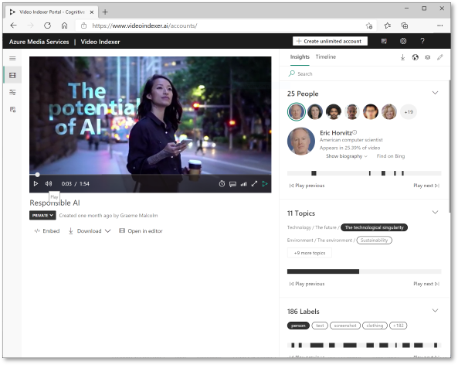

# 

# 

# **Extract custom insights**

Azure Video Indexer includes predefined models that can recognize well-known celebrities, do OCR, and transcribe spoken phrases into text. You can extend the recognition capabilities of Video Analyzer by creating custom models for:

* People. Add images of the faces of people you want to recognize in videos, and train a model. Video Indexer will then recognize these people in all of your videos.  
   Note  
  This only works after [Limited Access](https://aka.ms/cog-services-limited-access) approval, adhering to our Responsible AI standard.
* Language. If your organization uses specific terminology that may not be in common usage, you can train a custom model to detect and transcribe it.
* Brands. You can train a model to recognize specific names as brands, for example to identify products, projects, or companies that are relevant to your business.

# **Use Video Analyzer widgets and APIs**

While you can perform all video analysis tasks in the Azure Video Indexer portal, you may want to incorporate the service into custom applications. There are two ways you can accomplish this.

## **Azure Video Indexer widgets**

The widgets used in the Azure Video Indexer portal to play, analyze, and edit videos can be embedded in your own custom HTML interfaces. You can use this technique to share insights from specific videos with others without giving them full access to your account in the Azure Video Indexer portal.

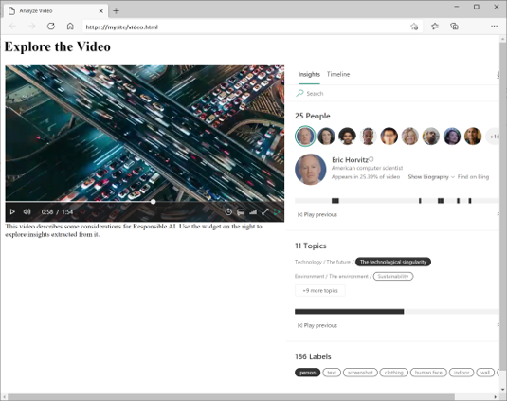

## **Azure Video Indexer API**

Azure Video Indexer provides a REST API that you can use to obtain information about your account, including an access token.

HTTP

<https://api.videoindexer.ai/Auth/><location>/Accounts/<accountId>/AccessToken

insights, and creating or deleting custom models.

For example, a GET call to https://api.videoindexer.ai/<location>/Accounts/<accountId>/Customization/CustomLogos/Logos/<logoId>?<accessToken> REST endpoint returns the specified logo. In another example, you can send a GET request to https://api.videoindexer.ai/<location>/Accounts/<accountId>/Videos?<accessToken>, which returns details of videos in your account, similar to the following JSON example:

{

"accountId": "SampleAccountId",

"id": "30e66ec1b1",

"partition": null,

"externalId": null,

"metadata": null,

"name": "test3",

"description": null,

"created": "2018-04-25T16=50=00.967+00=00",

"lastModified": "2018-04-25T16=58=13.409+00=00",

"lastIndexed": "2018-04-25T16=50=12.991+00=00",

"privacyMode": "Private",

"userName": "SampleUserName",

"isOwned": true,

"isBase": true,

"state": "Processing",

"processingProgress": "",

"durationInSeconds": 13,

"thumbnailVideoId": "30e66ec1b1",

"thumbnailId": "55848b7b-8be7-4285-893e-cdc366e09133",

"social": {

"likedByUser": false,

"likes": 0,

"views": 0

},

"searchMatches": [],

"indexingPreset": "Default",

"streamingPreset": "Default",

"sourceLanguage": "en-US"

}

## **Deploy with ARM template**

Azure Resource Manager (ARM) templates are available to create the Azure AI Video Indexer resource in your subscription, based on the parameters specified in the template file.

For a full list of available APIs, see the [Video Indexer Developer Portal](https://api-portal.videoindexer.ai/).

**Knowledge check**

1. You want Azure Video Indexer to analyze a video. What must you do first?

Use the Azure AI Vision service to extract key frames from the video.

Upload the video to Azure Video Indexer and index it.

That's correct. You need to index a video before analyzing it.

Store the video file in an Azure blob store container.

2. You want Azure Video Indexer to recognize brands in videos recorded from conference calls. What should you do?

Edit the Brands model to show brands suggested by Bing, and add any new brands you want to detect.

That's correct. You can both detect known brands, and well as include new brands you want to detect by providing information about it.

Edit the conference call videos to include a caption of each brand seen on their first appearance.

Embed the Azure Video Indexer widgets in a custom web site that **has all the brand images stored for reference.**